Temperature Chamber Documentation

# Introduction

This example demonstrates the implementation of a simple temperature chamber controller application using the Tag Bus Data (TBD) Framework. The goal of this example is to provide a baseline understanding of how the framework works, of the benefits that it provides, and of the workflow required to build your own applications. This document will walk you through the example step by step, show you how to get it running, and point out helpful features and terminology along the way.

The example includes two implementations. The first makes use of a simulated system with a simple model of a temperature controller. The second implementation uses real-world I/O in combination with a model and requires both a cRIO and a temperature chamber to make full use of its features.

# Simulated System Example

## Configuration Editor

TBD allows users to specify a large portion of their application’s behavior through a configuration file. As a result, viewing the system configuration file is often the best place to start for understanding a TBD implementation.

1. Open up the Standard Configuration Editor for TBD by navigating in LabVIEW to **Tools>>TBDF>>Launch Standard Configuration Editor…**

This is the default editor for the framework and is used to view and modify system configurations. It may take a few seconds to load as it searches for and loads into memory the various framework plug-ins. Before loading up this example’s configuration file, first ensure that the editor can find all of the Tag Bus Module (TBM) plug-ins that are a dependency of this configuration. Any plug-ins installed to vi.lib are found by default.

1. Navigate within the editor to **Tools>>Edit Plugin Search Paths**.
2. Add a search path to the TBM plugins for this example located at …<file path>. if this path doesn’t already exist. Also confirm that the standard vi.lib file paths are specified as shown below for the version of LabVIEW that you are using.

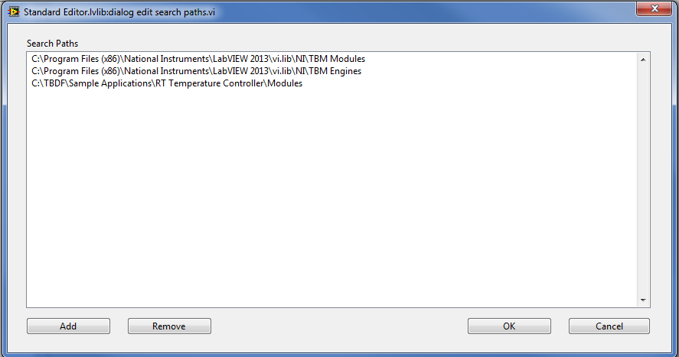

<UPDATE WITH CORRECT INSTALL LOCATION>

1. Click **OK** to confirm the new search path. The configuration editor will now scan these directories for any TBM plugins and load them into memory.
2. Once the busy cursor disappears, open up the configuration file for this example called **SimulatedSystem.pcfg** (stored in the same directory as the example project) using **File>>Open**.

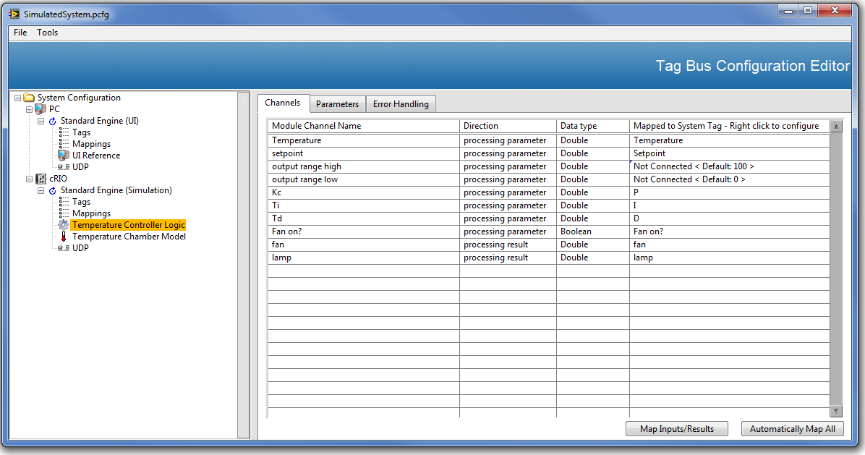

You should now see a tree control populated on the left side of the editor with a hierarchal set of items. Clicking on an item in the tree control populates the view on the right which can be used to edit that item’s configuration. Feel free to explore the editor by clicking various nodes within the tree control. The top-level node is the System. It has properties for the configuration version and description. Each System is comprised of one or more Targets that have an IP address, operating system and other properties. Each Target configuration is then comprised of one or more Engines.

An Engine is essentially a background process with a timing source and a collection of named locally-scoped current value data (Tags). Each Engine can be configured to execute one or more Tag Bus Modules (TBMs). Mappings are used to specify the exchange of data within a TBM (called a Channel) with the Tag data in the engine. Two TBMs can share data with each other by mapping their input and output channels to the same Tag alias.

For this particular system configuration, you will see that the cRIO has an Engine that is configured to execute both a model (which simulates the temperature chamber and its I/O) and the temperature controller logic (in this case just simple PID). Inspect the ‘Tags’, ‘Mappings’, ‘Temperature Controller Logic’, and ‘Temperature Chamber Model’ under the ‘Standard Engine (Simulation)’ node to see how the Channels of the model and controller are connected through Tags.

The diagram below provides a different visual representation of TBMs, Channels, and Tags. In the diagram, each colored row represents a TBM method. The entries under the TBM method represent the Channels of that TBM. The free floating labels represent Tags, and the connection of a Channel to a Tag to another Channel is represented as a wire.

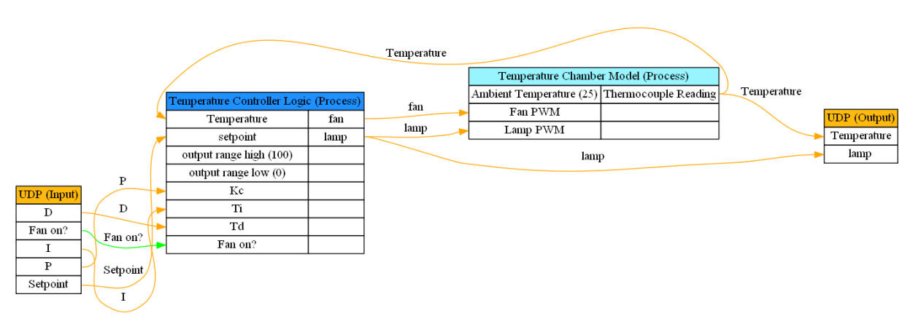

Also notice that both the ‘Temperature Controller Logic’ and ‘Temperature Chamber Model’ have at least one Channel that isn’t mapped to a Tag in the Engine. For any Channel that is unmapped, the default value of that Channel can be specified instead.

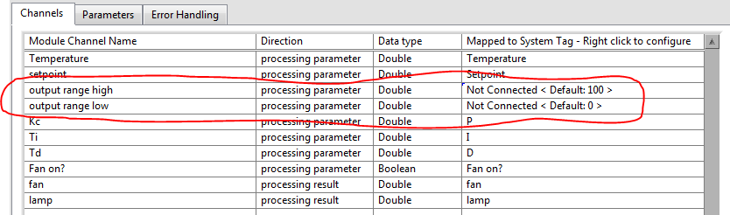

In addition to calling TBMs and exchanging data between them, the engine is also responsible for determining the execution rate of the system as well as the error handling configuration for each module. Click on the ‘Standard Engine (Simulation)’ node in the tree to see how these are configured for this system.

The PC in this configuration is serving as a UI. The UI provides the setpoint for the temperature controller as well as the command signal to turn on the fan disturbance. It also allows an operator to manipulate the PID gains. Status information regarding the operation of the controller is then returned and presented on this UI.

Data is transferred between the Simulation and UI engines using two instances of a UDP TBM. Each engine has its own instance and the two instances are paired together. All Tag data within an engine can only be access by TBMs within that engine unless exposed by a TBM. In this case the UDP TBM is used to reflect tag data between the two engines.

This configuration must be modified to properly reflect the IP addresses of your execution targets.

1. <WINDOWS ONLY> If running this configuration purely on your local Windows machine, modify the configuration so that the Engine on the cRIO runs on the PC instead. To do this, click the **Standard Engine (Simulation)** node under the engine and drag it up to the PC.

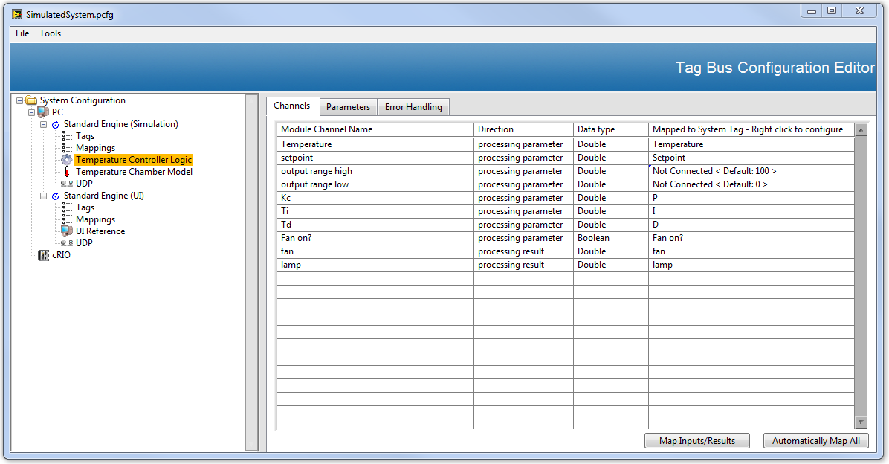

1. Ensure proper IP addresses for both UDP modules.
   1. <WINDOWS ONLY> Set the **send to address** field on the **Module Settings** tab for both UDP modules to **localhost**.
   2. <WINDOWS and cRIO> Set the **send to address** on the **Module Settings** tab on the PC UDP module to the IP Address of the cRIO and vice versa for the cRIO UDP module. Be sure to specify the actual IP address and not use a value of **localhost**.

The configuration is now ready to be loaded on your target(s) and executed. The local PC already has access to the configuration file, but for the cRIO to execute it the file must be stored on the cRIO’s hard drive.

1. Save your changes to the configuration file by navigating within the editor to **File>>Save**.
2. <WINDOWS and cRIO> Click the cRIO target in the configuration editor and enter its IP address in the **IP** field. Then navigate to **Tools>>Deploy** **Tool**, click the cRIO target in the targets list, and then click the **Deploy** button. Ensure that you see a Success dialog appear.

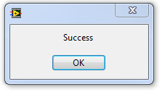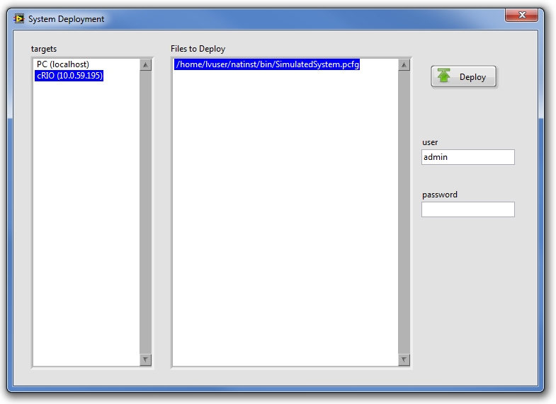

## ‘Host Main.vi’

Now that we’ve explored the system configuration for this example, let’s take a look at the LabVIEW code that will execute it. Leave the configuration editor open as you may want to refer to it again.

1. Open the **Temperature Controller Example.lvproj** if it isn’t already open. Then open the **Host Main.vi** from the project and inspect its Block Diagram.

<ADD SCREENSHOT HERE>

This is a simple example that opens up a configuration file, loads the engines and modules that the configuration contains, and then runs them until told to stop or an error occurs. The majority of this code is generic to any system configuration with two exceptions. The first is the ‘User Interface.vi’ which has UI elements specific to the example. Notice that the Block Diagram of this VI is essentially empty. This is because the ‘UI Reference’ TBM is able to write and read to controls and indicators directly as specified in the configuration. The ‘UI Reference’ TBM just needs the name of the VI and the specific controls and indicators to interact with.

The other application specific code resides in the ‘Host Module Includes.vi’. The purpose of this VI is to load into memory the Engines, TBMs, as well as any other plug-in code specified by the configuration file. This VI should be updated anytime a TBM is deleted or a new TBM is added to the configuration in order to reflect the new dependencies. Because the editor is aware of these dependencies, the editor can update this VI for you automatically.

1. <OPTIONAL> Navigate to the PC target in the editor and add the file path to the **Host Module Includes.vi** in the **Module Includes File Path** field.

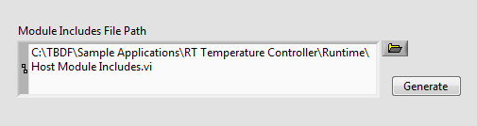

While the editor can update these includes for you, you will still need to remember to click Generate when the plug-in dependencies change. Failing to do so will result in either a loading error or in having more dependencies than necessary in memory.

The framework was also designed so that TBMs could be built and deployed as plug-ins on disk which get loaded into memory dynamically at runtime instead of being statically included. When taking this approach the ‘Host Module Includes.vi’ would no longer be necessary, but source distributions would need to be created for each plug-in and code would need to be added to load those plug-ins into memory before loading up a configuration file.

To recap, the ‘Host Main.vi’ will load and execute a system configuration created by the editor. It has two clearly defined locations for placing application specific code related to the framework, one of which can be kept up to date automatically by the editor and the other is the application specific user interface. It’s worth pointing out that it’s also possible to implement additional functionality alongside the framework as part the main VI. TBD doesn’t require that it’s used for every aspect of an application and can instead be applied for the tasks that make the most sense.

We are now ready to run the host application.

1. Run ‘Host Main.vi’.

You should see the following User Interface appear which will allow you to specify the temperature setpoint, tune the PID gains, turn the disturbance on and off, and monitor the resulting temperature and lamp intensity. If you are running this example purely on the PC, the host will also run the Simulation Engine and you will also see data appear in the graph. Otherwise it will appear as below until the ‘cRIO Main.vi’ begins running as well.

## 

## ‘cRIO Main.vi’

Whether you have access to a cRIO or not, let’s take a look at the cRIO application. Continue to leave both the configuration editor and the ‘Host Main.vi’ open and running.

1. Open up and inspect ‘cRIO Main.vi’ in the project.

<SCREENSHOT HERE>

This application is very similar to the ‘Host Main.vi’ except that the Engine API functions are contained within a background service that receives commands through a queue. This service is useful because it allows system configurations to be loaded and unloaded repeatedly without requiring a reboot to the controller. It also allows a developer to pipe commands to start and stop the engine over the network instead of generating them locally.

Like the ‘Host Main.vi’, the ‘cRIO Main.vi’ has two places where application specific code resides. There is a ‘cRIO Module Includes.vi’ which serves the same purpose as the ‘Host Module Includes.vi’.

1. <OPTIONAL> Navigate to the cRIO target in the editor and add the file path to the **cRIO Module Includes.vi** in the **Module Includes File Path** field.

There is also a debugging loop with a collection of application specific Current Value Table (CVT) tags. Ignore this code for now. It isn’t used for this example and will be explored as part of the ‘FullSystem.pcfg’ file which we will examine later.

If you are using a cRIO with this example, and the configuration file is deployed to the target, go ahead and run ‘cRIO Main.vi’.

1. <WINDOWS and cRIO> Run ‘cRIO Main.vi’.

Once running, you should now see data appear on the ‘Host Main.vi’. (If you don’t, make sure that your IP settings for the UDP module are specified properly in the system configuration and that your firewall isn’t blocking the UDP communication.)

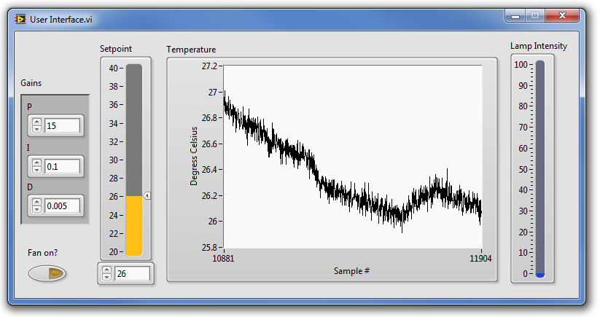

## Fixed-Channel TBMs

Now let’s take a second look at the four TBMs used for this example within the configuration editor: Temperature Controller Logic, Temperature Controller Model, UI Reference, and UDP. Of these, the UI Reference and UDP modules could be valuable tools for any project (which is why they are installed to vi.lib). However the Temperature Controller Logic and Temperature Controller Model are both very specific to this example application.

This is a theme common to many applications. Data services and I/O plug-ins tend to be reusable elements while control logic tends to be application specific. In addition to many of the pre-built data service and I/O TBMs, the TBD framework also includes a Fixed-Channel sample project to aid users in the creation of their own control logic plug-ins. This template can be used for any functionality with a fixed set of inputs and outputs (UDP and UI Reference both support a dynamic number of inputs) and was used to create the Temperature Controller Logic and Temperature Controller Model functions.

This template can make the creation of new plug-ins as simple as putting control logic within a single VI. Open up <file path> .

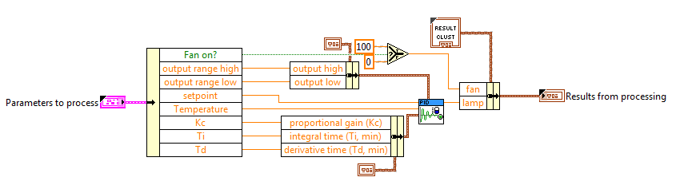

As you can see, this VI uses a cluster ‘Parameters to process’ to define its inputs, and a different cluster ‘Results from processing’ to define its outputs. The data in these clusters corresponds to Processing Parameters and Processing Results respectively. Changes to these clusters require rerunning the Fixed Channel Module Script from LabVIEW **Tools>>TBDF>>Fixed Channel Module Script…**  The script uses the information in these clusters to generate the remaining TBM code including the editor UI. In the simplest case, creating a TBM to execute code inline with the engine can be as simple as using the Fixed Channel Sample Project and placing your logic within a single VI.

## Simulated System Example Summary

The Simulated System example demonstrates how to create and modify a system configuration in the configuration editor, deploy a configuration to a target, and update that target’s plug-in dependencies. We have also discussed the technology behind the creation of the example’s control logic.

# Full System Example

This example makes use of real-world I/O connected to a temperature chamber. Although you likely don’t have the hardware dependencies necessary to actually run the example, much can still be learned from examining the implementation.

1. From the Standard Configuration Editor, open the **FullSystem.pcfg**.

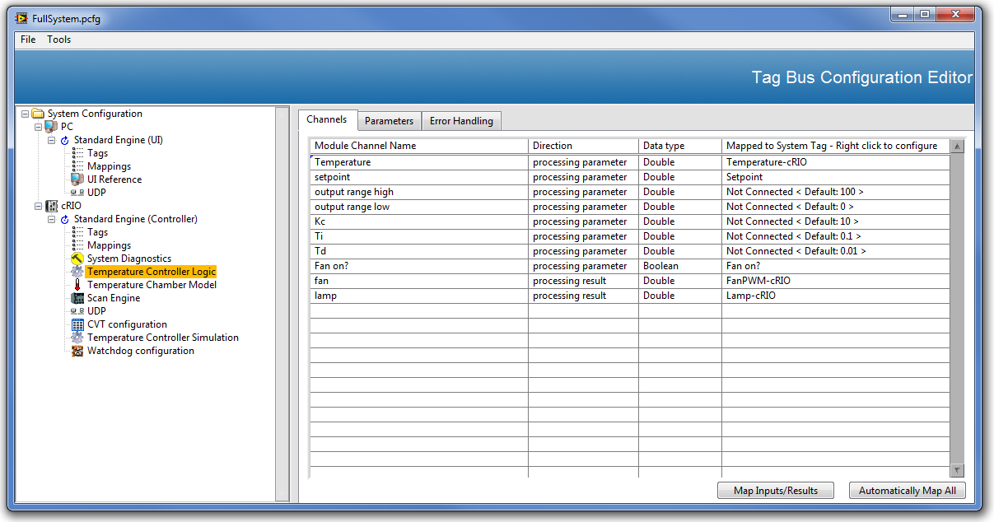

The first thing to notice is that the cRIO target has been configured to run additional TBMs. It now includes the Scan Engine TBM to interact with real world I/O and an additional controller for the real temperature chamber that is connected to that I/O. This means that the cRIO is configured to simultaneously control both a model and the real world.

There are also some TBMs added for utility. The first is System Diagnostics which returns CPU and memory usage of the system. The next is the Watchdog module which will automatically reboot the controller if it doesn’t run at least once during the timeout period. The last additional TBM is the Current Value Table (CVT) which is used to expose specific data in the engine for global access by any code running on that target. Reopen the ‘cRIO Main.vi’ and see how its CVT tags are configured in the editor by the CVT configuration.

The diagram below provides visual representation of the TBMs, Channels, and Tags for this configuration. The diagram uses the same conventions as the one above, but omits the Tag labels for the wires.

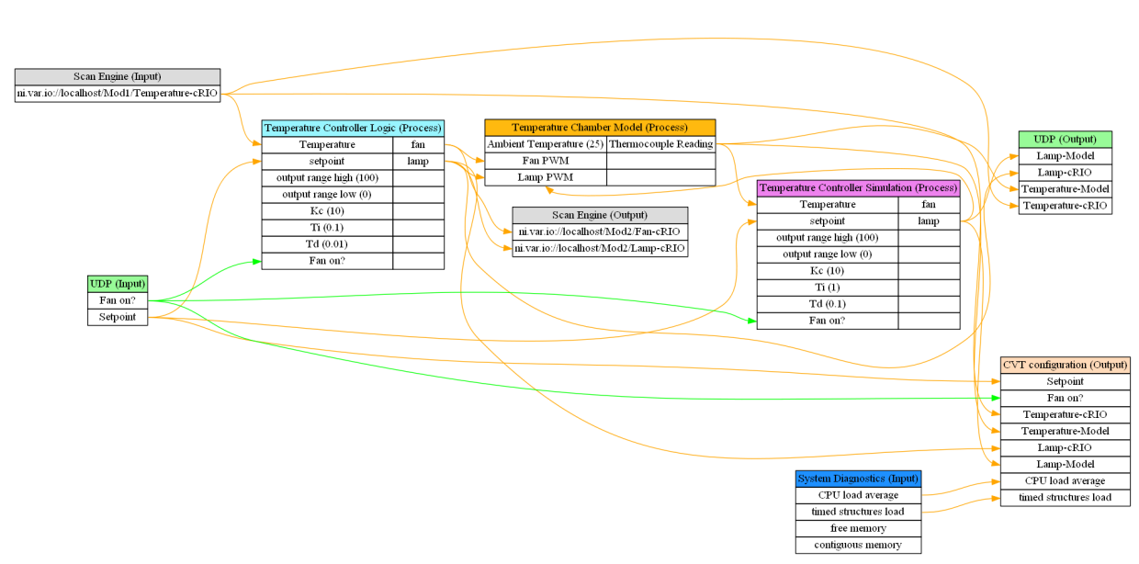

## Full System Example Summary

There are a few key takeaways from this example. The first is that the example uses the exact same TBMs, ‘Host Main.vi’, ‘User Interface.vi’, and ‘cRIO Main.vi’ as the Simulated System example. In fact, other than the new TBMs add to the cRIO target in the configuration file, the only difference between the two examples is the additional dependencies required by the cRIO target’s Module Includes vi.

This example also demonstrates how the framework can allow users to easily switch between simulated I/O and real world I/O for the benefits of testing and productivity. The framework also allows the execution of any simulated I/O alongside the real I/O for the purposes of comparison and diagnostics.

Another takeaway is that despite the benefits of running code within the framework through the creation of new TBMs, various escape hatches like the CVT module allow for the development of code that can easily execute alongside the framework. Using mechanisms like the CVT, the framework can be used to simply integrate single-point data from a variety of sources and expose it through a common API.

# Building Your Own Application

We have now covered how the configuration editor, the Host Main, the cRIO Main, and the Fixed Channel TBM can be put together with existing TBMs to implement a simple application. The TBD includes a collection of sample projects to help users generate their own versions of this code for their own applications.

To find these sample projects, navigate in LabVIEW to **File>>Create Project…** and click on the TBDF category.

<Screenshot Here>

The <name here> sample project can be used to create a new VI very similar to the ‘cRIO Main.vi’. This sample project is a good starting point for applications that need the ability to load new configurations without rebooting or need to receive engine commands from another target.

The <name here> sample project can be used to create a new VI that is very similar to the ‘Host Main.vi’. This sample project is recommended for simple applications where getting something up and running quickly and easily is desired.

The <name here> sample project can be used to create new Fixed Channel TBMs. This sample project offers a table where a user can specify all of their TBMs inputs and outputs as well as a few other properties. Once entered, it will then script out the clusters and other code to allow for the simple creation of TBMs like the Temperature Controller Logic used in these examples.

The <name here> sample project can be used to create your own copy of the Configuration Editor. The use of this sample project is not recommended unless significant customization of the configuration editor is required. While much of the Standard Configuration Editor’s code is built from underlying framework elements that are updateable, it also includes some of its own features. The use of this sample project amounts to a branch from the Standard Configuration Editor that will have to be maintained independently.

The other sample projects included by the framework are out of scope of this document as they do not relate to topics covered by these examples.

How do we want to wrap this up?